# Add Task Use Case

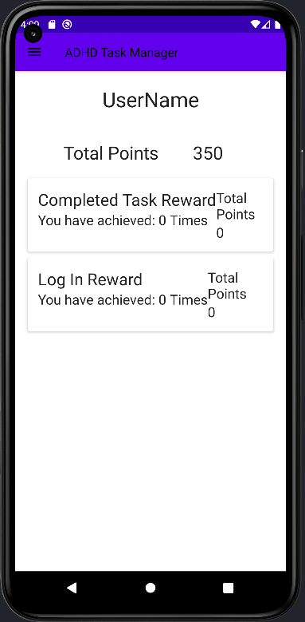Initialized the App, There is no previously added tasks or previous awards achieved.

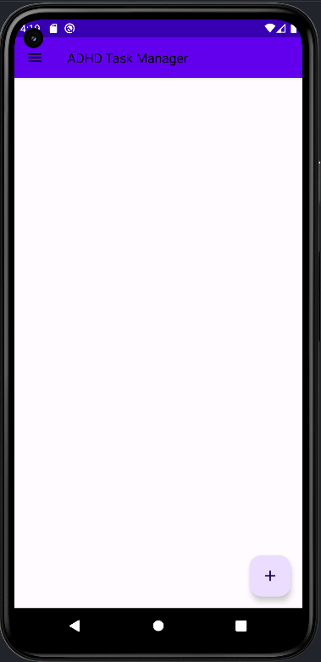

Clicking on the + Button on the bottom left of the Todo/Home Screen, will open the todo Dialog Screen which is an overlay over the top of the TodoScreen

The Expected Result was for this dialog to open and it did.

The next step is to enter some information into the fields.

Clicking on the Date and Time boxes open up their own material dialogs for the user to select Date and Time variables.

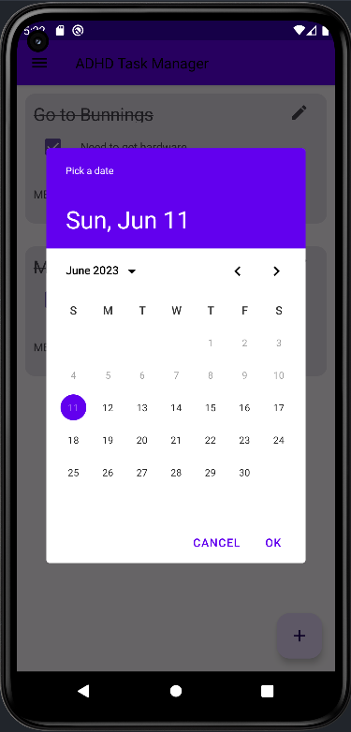

Clicking on the Add Button on the dialog adds the Todo Task into the local Room Database and displays it on the Todo/Home Screen:

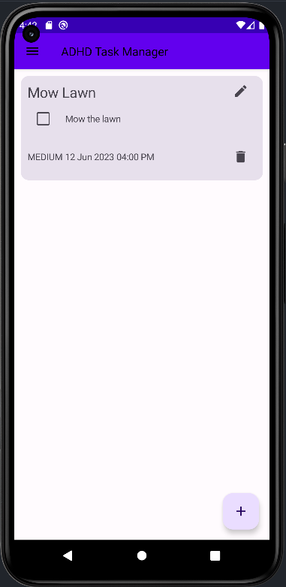

Here is some evidence of adding a second task:

# Completed Task Use Case:

Requirements for this use case is an added task. Here we have two tasks incompleted and still have not

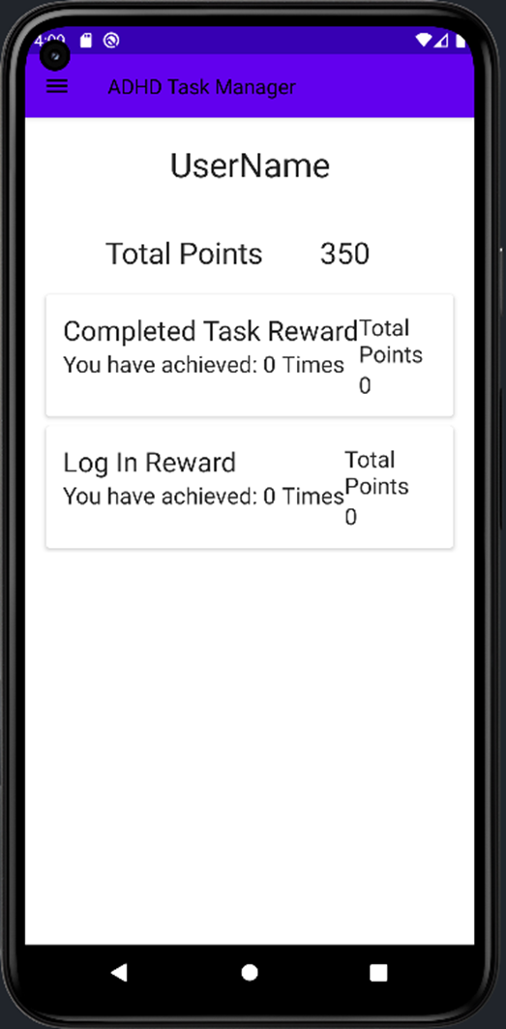

Clicking on the check box will mark the task as completed

Clicking on the completed checkbox updates the Reward Database. In this case, The Completed Task Reward requirement was satisfied so it updated the amount of times this award has been achieved. It can be viewed on the Reward Screen of the application. At this moment, the user should click on the Navigation Icon on the Top Left to open the Navigation Menu.

Clicking on the Rewards Screen opens up all the possible awards a user can achieve and shows how many times it has been achieved. At this stage there is just two rewards to display. As you can see, after clicking the task as complete on the Todo Screen, the reward screen has updated to display that we have achieved it once and achieved 3 points from it

Going back and completing the second task, will update the reward again.

